**DAILY ONLINE ACTIVITIES SUMMARY**

|  |  |  |  |  |  |  |  |  |
| --- | --- | --- | --- | --- | --- | --- | --- | --- |
| **Date:** | **12-6-2020** | | | | | **Name:** | **Likhitha.M** | |
| **Sem & Sec** | **6th sem ‘A’** | | | | | **USN:** | **4al17cs046** | |
| **Online Test Summary** | | | | | | | | |
| **Subject** | | **None** | | | | | | |
| **Max. Marks** | | **-** | | **Score** | | | **-** | |
| **Certification Course Summary** | | | | | | | | |
| **Course** | **Front end Development- HTML** | | | | | | | |
| **Certificate Provider** | | | **Great learning** | | **Duration** | | | **3 days** |
| **Coding Challenges** | | | | | | | | |
| **Problem Statement:**  1.Write a Python program to implement Magic Square  A magic square of order n is an arrangement of n^2 numbers, usually distinct integers, in a square, such that the n numbers in all rows, all columns, and both diagonals sum to the same constant. A magic square contains the integers from 1 to n^2.  2. Python program to print the pattern  3.Write a Java program to find maximum width of a binary tree | | | | | | | | |
| **Status: completed** | | | | | | | | |
| **Uploaded the report in Github** | | | | | **yes** | | | |
| **If yes Repository name** | | | | | **https://github.com/likhithaMantaral/Daily-status** | | | |
| **Uploaded the report in slack** | | | | | **yes** | | | |

Certification Course Details:

**Front end Development- HTML**

* Introduction to HTML
* Creating HTML file.

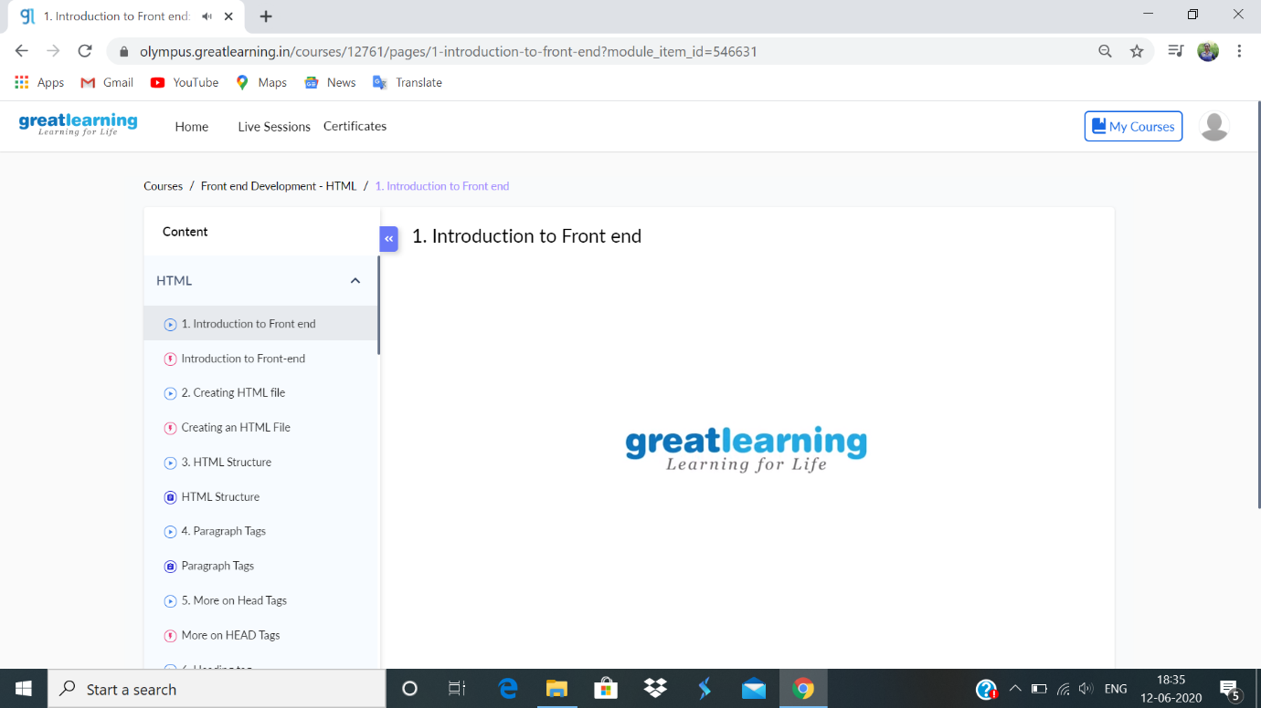

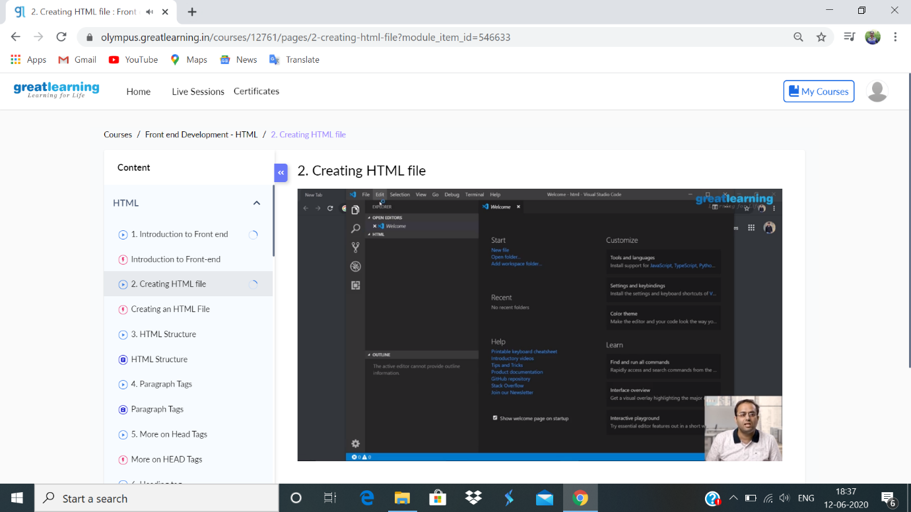

**Coding challenge:**

**1.**

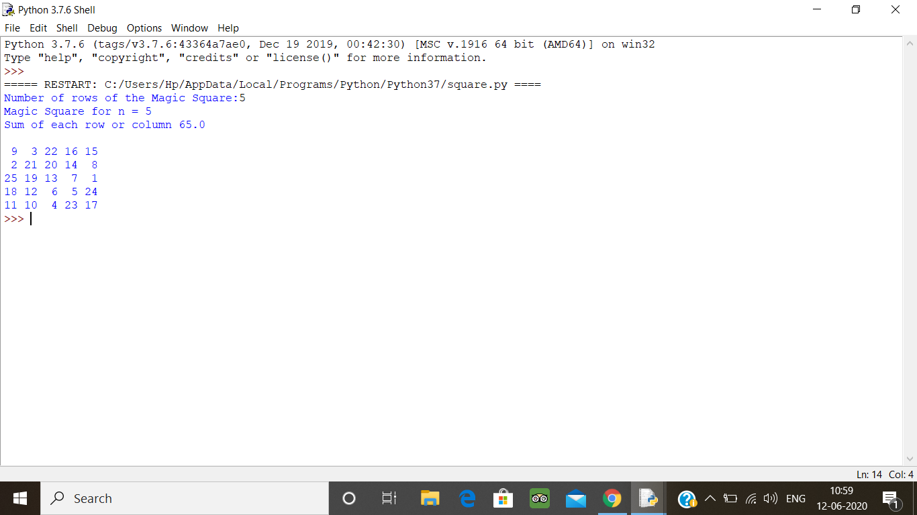

2.

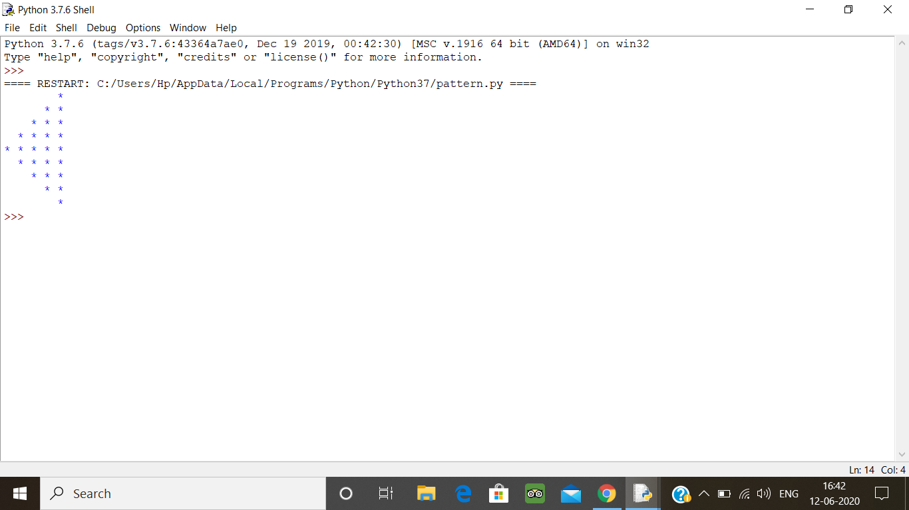

3.

